Name:

Resource Rich Section

TIME ALLOWED: 15 min Total marks: 17

Question 10 [2 marks]

Solve:
for

Question 11 [4 marks]
Describe how to transform the graph of to obtain the graph of

Question 12 [2 marks]

If P(x) = 2x⁴ + 4x³ + 2x² – 5x – 8, find P(4)

Question 13 [9 marks]
A small object is moving in a straight line towards and away from a fixed point.
The horizontal distance, d m, of the object from at time t seconds is given by the function.
.
(a) Determine the distance of the object from when . (1 mark)

(b) Draw the graph of on the axes below for . (3 marks)
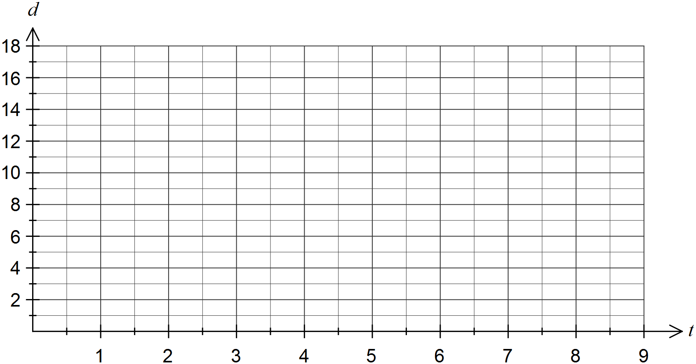

(c) State the amplitude and period of the graph of . (2 marks)

(d) Determine the time, to the nearest tenth of a second, when the object was first at a distance of 16 metres from . (1 mark)

(e) Determine the distance travelled by the object between and . (2 marks)

END OF TEST

